
 | MoonLake Investor Day: Positive readout for sonelokimab’s Phase 2 S-OLARIS in AxSpA; On track for BLA submission for HS in Q3 2026; PsA IZAR-1 & 2 readouts in 2026
 | Company: MoonLake Immunotherapeutics  Drug: Sonelokimab (SC, IL-17A/F nanobody) | Date: February 23^{rd,} 2026  Source(s): Press Release; Presentation
What happened:
- Moonlake hosted an investor day announcing Q4 and FY 2025 financial results along with positive topline results from sonelokimab’s Ph2 S-OLARIS study in radiographic and non-radiographic axSpA and updates on HS program
- AxSpA: 12-week results from Ph2 S-OLARIS study in adults (N=26) showed that sonelokimab demonstrated clinically meaningful and statistically significant benefit
  - ~77% ASAS40 at Week 4 and >80% ASAS40 at Week 12, with “unprecedented speed of onset” and a high magnitude of responses
  - 89% ASDAS-CRP (inactive or low disease activity) at weeks 4 and 12; 81% achieved clinically important improvement at week 12
  - Assuming Ph3 commencement in H2 2026, US/EU approval for AxSpA anticipated Q4 2029
- PsA: Ph3 IZAR-1 & 2 trial primary endpoint readouts for PsA are expected in Q2/Q3 2026 and Q4 2026, respectively (earliest US/EU approval for PsA anticipated in Q3 2028)
- HS: On track for BLA submission in Q3 2026, with launch guided to Q3 2027 (in line with previous expectations; launch guided for Q3 2027)
  - VELA-1 (Ph3) and MIRA trial (Ph2) to be submitted to establish substantial evidence of effectiveness (SEE) and to support safety. VELA-2 to be submitted for safety, its use to establish SEE will be discussed
  - VELA-TEEN will support differentiation in label through adolescent data (12+yrs)
  - Interim 52-week data released; HiSCR75 responses at 67-69% at 52 weeks (positioned as better than Bimzelx and Cosentyx); full data in Q2 2026
    - The VELA trials are still ongoing and MoonLake did not specify how many patients had reached the 52-week timepoint; data are subject to change when final clinical study reports are released

Impact (CI PoV): MEDIUM
- Moonlake is positioning sonelokimab as a next-generation tri-specific IL-17A/F nanobody with a favorable safety profile
  - Highlighted “disease modifying” potential in AxSpA. While sonelokimab offered compelling Phase 2 data; however, results were generated in a small cohort (~30 patients), open label study without placebo group, making Phase 3 confirmation critical to validate magnitude, durability, and competitive differentiation
  - Management bullish around regulatory submission pathway for HS without need for additional studies despite mixed Ph3 results; continues to believe asset is well positioned to be differentiated vs on market competitors

Why it matters (CI Insights in blue italics):
- Sonelokimab underpins MoonLake’s portfolio strategy, with multi-indication expansion across immunology supporting its narrative as a pipeline-in-a-product with broad immunomodulatory potential
- Sonelokimab is seeking to “break the treatment level” with a next generation multi-domain approach that aims at “changing the treatment paradigm” across disease states

Tell me more:
Financial Highlights
- Cash & equivalents: $394 M (vs $322 M in Q3 2025) + gross proceeds of $75 M from equity runway to H2 2027
- R&D expenses: $56 M (vs $61 M in Q3 2025)
- G&A expenses: $9 M (vs $11 M in Q3 2025)

Immunology Portfolio (CI Insights in Blue Italics)
Sonelokimab (SLK) – SC IL-17A/F Nanobody (HS, AxSpA, PsA, PPP)
- HS (Ph3 VELA-1 & VELA-2; Ph2 MIRA; Ph3 VELA-TEEN)
  - BLA submission: Reiterated outcomes of Type B meeting with FDA which confirmed that VELA-1, -2 and MIRA can be submitted, with no additional trials required
    - VELA-1 and MIRA to be used to establish SEE and support the safety profile; VELA-2 will primarily support safety
    - MIRA was highlighted as a large clinical trial (N=234) that is adequate and well controlled with PBO and SOC, similar in design to Ph3 program. Together with VELA program this accounts for three well-controlled and adequate trials for regulatory submission (unlike competitors unable to use Phase 2 as pivotal)
  - Label design: HS label will be designed for competitiveness and differentiation
    - Differentiation to be reflected in the clinical data section (Section 14: differentiated efficacy with inclusion of Pain NRS‑3, HiSQoL, and IHS4‑55% endpoint data to support prescription), warnings & precautions section (Section 5: differentiated safety-benefit ratio, with no SIBs, hepatic events, elevated transaminase, dermatitis, IBD or TB risks) and dosing section (Section 2: low injection volume, reduced frequency, and shorter induction period)
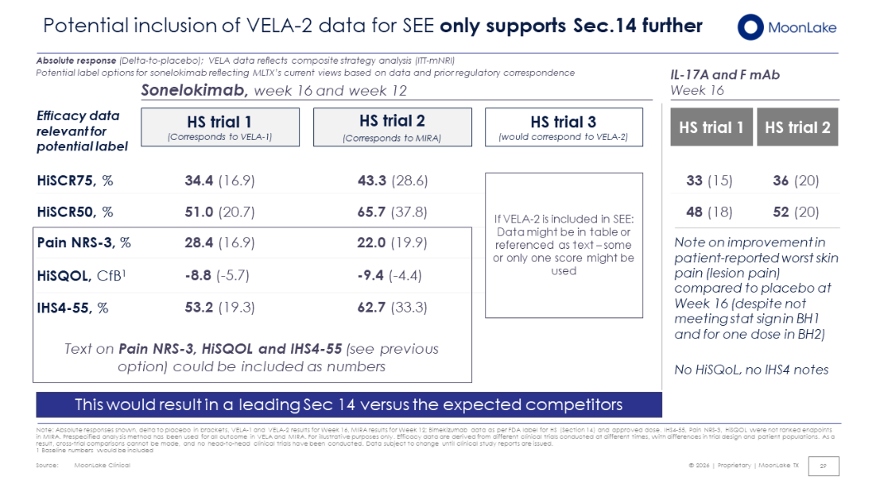
  - Long-term Ph3 VELA-1 & VELA-2: Efficacy data highlighted in comparison to Bimzelx and Cosentyx trials, demonstrating durability and supporting commercial positioning with HiSCR75 response rates of 69% and 67% in VELA-1 and VELA-2, markedly exceeding those reported in competitor studies
    - Continued improvement in pain and HiSQoL also highlighted as key endpoints to drive commercial traction; Nanobody MoA promoted as a key differentiating feature
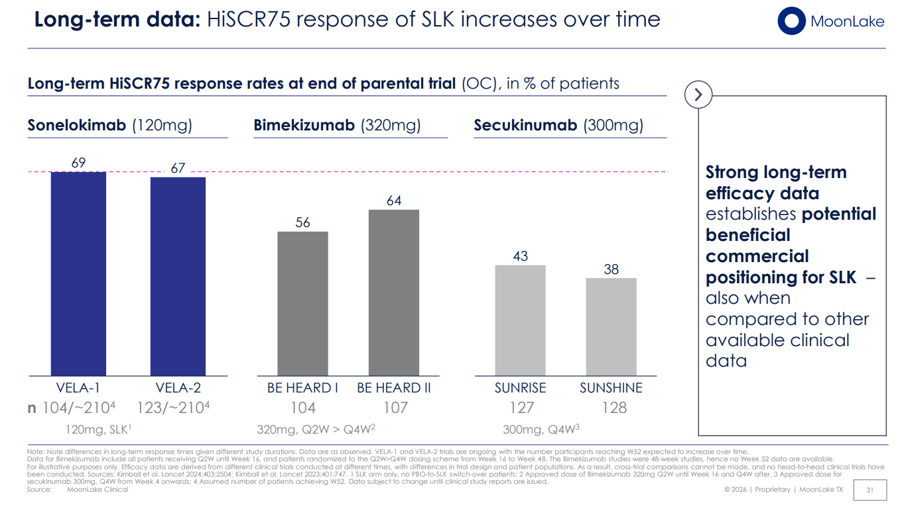
  - Commercialization: Manufacturing and distribution capacity in place to support up to four or five years of commercialization; pricing and formulary access expected to be on par with Bimzelx
    - SC auto‑injector (offering 1ml dose) has completed all required studies, is already being used in the HS OLE with strong positive patient feedback, and is expected to be the approved RoA at launch
  - Ph3 VELA-TEEN: Updated interim VELA-TEEN data demonstrating rapid and sustained response in adolescents at week 16 (n=21) through week 24 (n=12)
    - VELA-TEEN data to be included in data package as part of BLA submission to obtain a “broad label” and “address an unmet need”
  - Upcoming milestones (slide 35):
    - Pre-BLA meeting: early April; CMC pre-BLA: early May
    - VELA week 52 data: Q2 2026
    - VELA-TEEN Primary endpoint readout: mid 2026
    - BLA submission: Q3 2026; BLA acceptance: Q4 2026
- AxSpA (Ph2 S-OLARIS): S-OLARIS (met key efficacy endpoints (ASAS40, ASDAS-CRP and SPARCC MRI) and showed favorable safety at week 12
  - ASAS40: Management highlighted the low competitive benchmark (ASAS20 and ASAS40 rates typically around 40–50%), whereas sonelokimab achieved ~80%+ ASAS40 at Week 12 and demonstrated rapid responses by Week 4, ~77% vs ~21–35% for competitors (cross-trial comparison) - suggesting potential best-in-class differentiation (however, recall the small sample size and open-label design of this Ph2 trial)
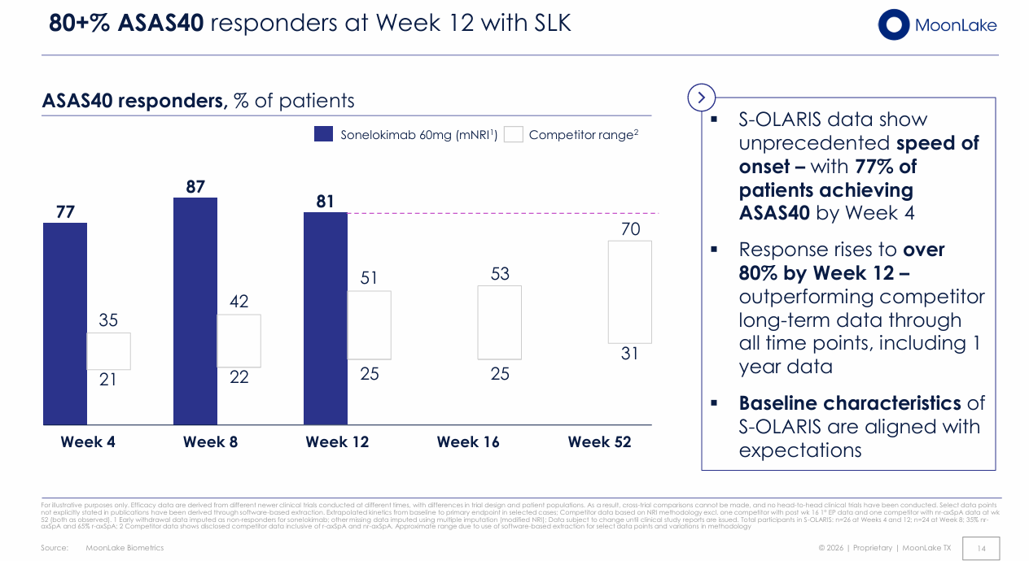
  - ASDAS-CRP:
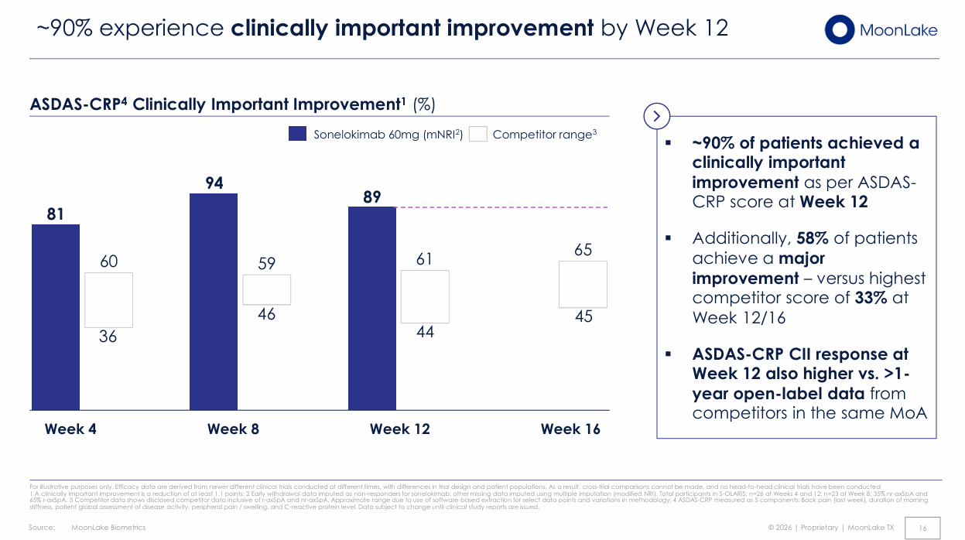
  - SPACC MRI score was -21.8 (90% score reduction), with 92% of patients achieving a decrease in SIJs at Week 12, outperforming competitor data
    - SUVmax score reduced by -43% at Week 12
    - Management further noted that no competitors are incorporating PET imaging at Phase 3
  - Multiple key serum biomarkers (LRG1, ORM1, TNFRSF8, APCS) associated with osteoblast activity, inflammation, angiogenesis and ossification were reported to strongly correlate with Week 12 ASDAS-CRP response, with management noting these biomarkers may serve as a biological control of disease activity
  - Safety profile was favorable described as consistent with prior PsA
    - As per MoonLake, favorable hepatic / liver profile, no signals related to suicidality, and potentially improved skin tolerability may offer potential areas of differentiation

- PsA (Ph3 IZAR-1 & IZAR-2; Ph2 P-OLARIS):
  - Phase 3 IZAR-1 and IZAR-2 topline readouts expected Q2/Q3 2026 and Q4 2026, respectively (in line with previous expectations of Q2 and H2 2026, respectively);
  - Phase 2 P-OLARIS interim readout expected in Q4 2026
  - CI expects US/EU approval in Q3 2028 as per MoonLake R&D day in Sep 2025

- PPP (Ph2 LEDA):
  - Phase 3 to initiate in Q3 2026 (in line with previous expectations) building on positive Phase 2 results and recently obtained FDA fast-track designation
  - Trial designed for an expedited readout with a week 12 primary EP (e.g. vs week 16 for BKZ)

Relevant Slides:

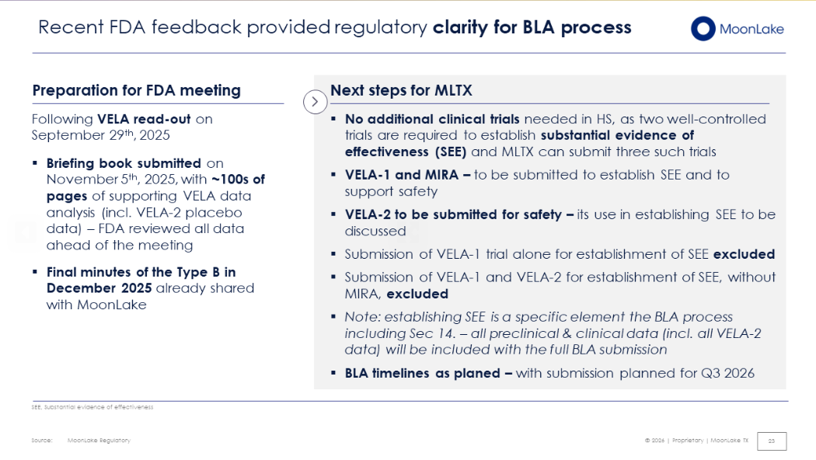

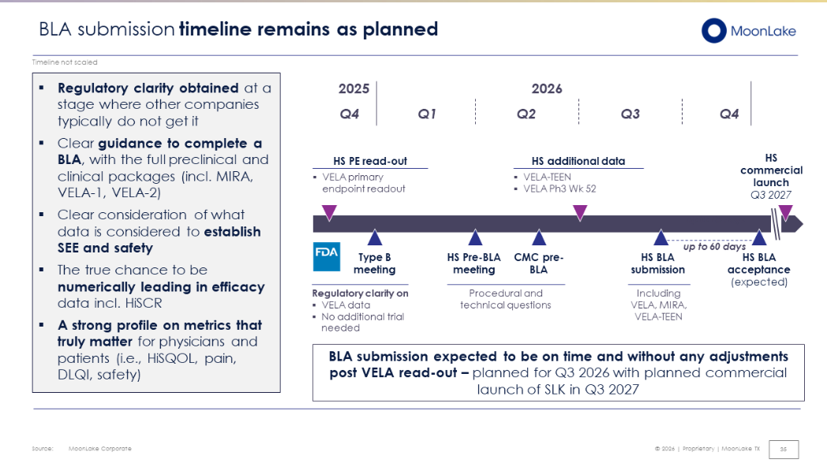

For questions, please reach out to:
 | Dermatology | Rheumatology | Gastroenterology
APEX (US/PCS) | Chanda Bhat | Bethany Christmann | Luke Versten
IMABI (International/ Affiliates) | Priti Anand | Irene Knorn | Priti Anand

Invite your colleagues to inVision | Manage Email Preferences | Unsubscribe

This document/email contains competitive intelligence collected via an approved competitive intelligence supplier working on behalf of AbbVie. We collect competitive intelligence consistent with industry standards and AbbVie policy. Not for field distribution. Please reach out to APEX/IMABI, Legal, or OEC teams with any questions.

